**Course Project   
DeVry University  
College of Engineering and Information Sciences**

***Screenshot of program running:***

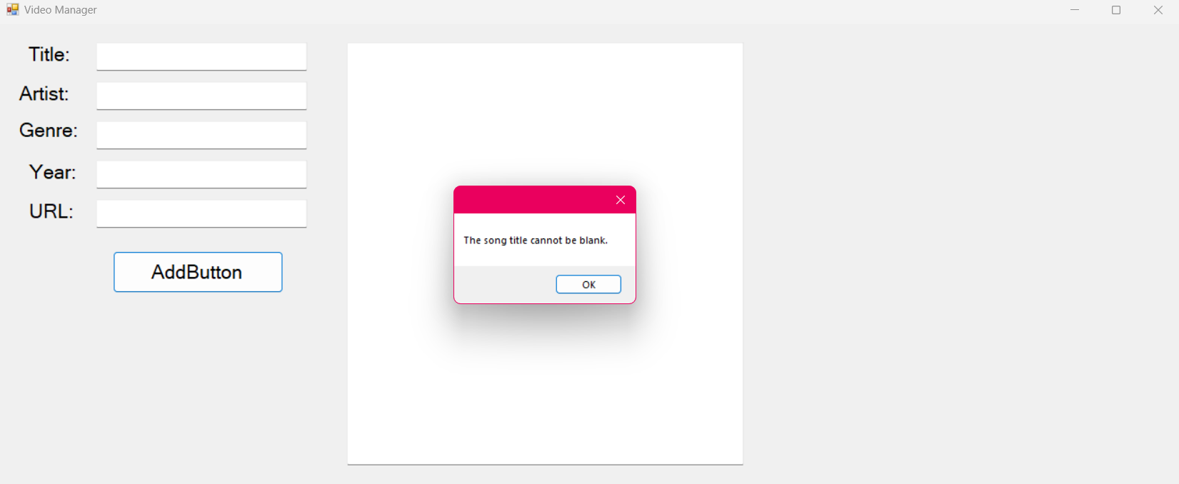

***Form code (only the code for the form, not program.cs):***

